Power BI Dashboard Documentation – Customer Churn Analysis
1. Dashboard Purpose
This dashboard provides a clear summary of customer churn behavior and highlights the key factors that influence customer retention. It is designed to support quick business decision-making.
2. KPI Section (Top of Dashboard)
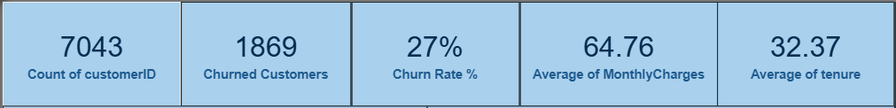
- Total Customers – 7043
What it shows: Total number of customers available in the dataset.
- Churned Customers – 1869
What it shows: Number of customers whose churn status is marked as Yes.
- Churn Rate – 27%
What it shows: Percentage of customers who have left the company.
- Average Monthly Charges – 64.76
What it shows: Average monthly billing amount per customer.
- Average Tenure – 32.37 months
What it shows: Average duration customers stay with the company.
3. Visual 1: Churn Rate % by Contract Type
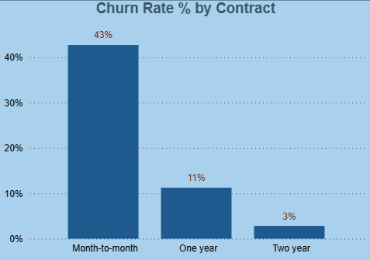
What it shows:
- Churn rate across different contract types.

Observed values on dashboard:
- Month-to-month → 43%
- One-year → 11%
- Two-year → 3%
Interpretation:
- Customers with month-to-month contracts churn significantly more than long-term customers.
Visible on dashboard: Bar chart titled 'Churn Rate % by Contract'.
4. Visual 2: Churn Rate % by Internet Service
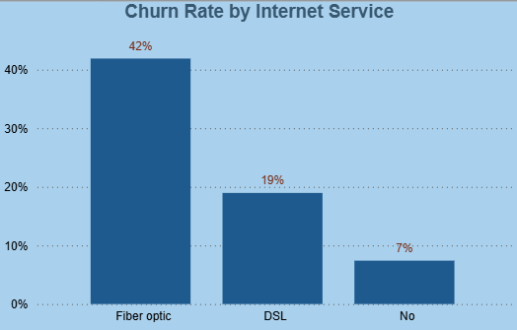
What it shows:
- Churn rate across different internet service types.
Observed values on dashboard:
- Fiber optic → 42%
- DSL → 19%
- No internet → 7%
Interpretation:
- Fiber optic customers have the highest churn compared to other service types.
Visible on dashboard: Bar chart titled 'Churn Rate % by Internet Service'.
5. Visual 3: Churn Rate % by Payment Method
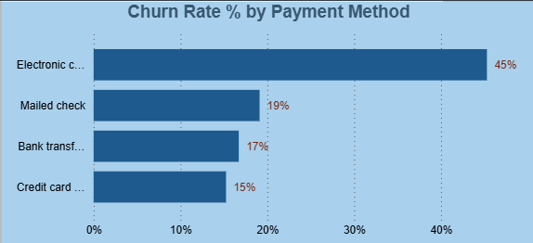

What it shows:
- Churn rate based on customer payment method.
Observed values on dashboard:
- Electronic check → 45%
- Mailed check → 19%
- Bank transfer (auto) → 17%
- Credit card (auto) → 15%
Interpretation:
- Customers using electronic check show the highest churn, while auto-payment users are more stable.
Visible on dashboard: Horizontal bar chart titled 'Churn Rate % by Payment Method'.
6. Visual 4: Churn Rate % by Customer Tenure
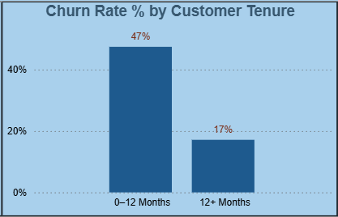
What it shows:
- Comparison of churn between new and long-term customers.
Observed values on dashboard:
- 0–12 months → 47%
- 12+ months → 17%
Interpretation:
- New customers churn much more than long-term customers.
Visible on dashboard: Column chart titled 'Churn Rate % by Customer Tenure'.

7. Visual 5: Churn by Senior Citizen
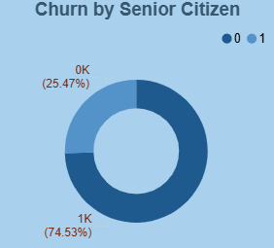
What it shows:
- Distribution of churn among senior and non-senior customers.
Interpretation:
- Senior citizens contribute a higher share to churn compared to non-senior customers.
Visible on dashboard: Donut chart titled 'Churn by Senior Citizen'.
8. Interactive Filters (Slicers)
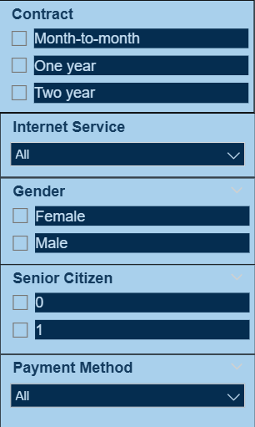
What it shows:
- Contract Type
- Internet Service
- Gender
- Senior Citizen
- Payment Method
These slicers allow dynamic filtering of all KPIs and visuals, enabling analysis of specific customer segments.

9. Overall Look and Layout of the Dashboard
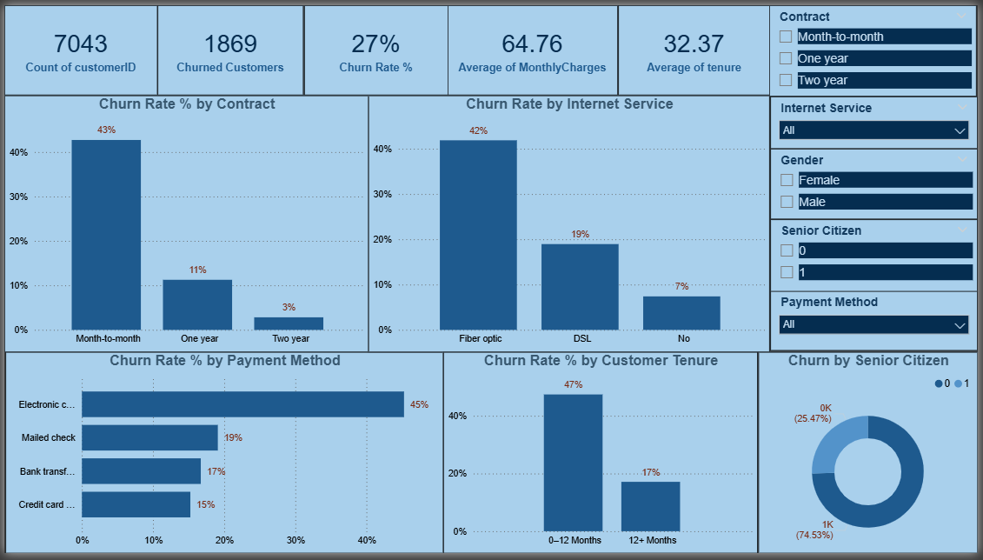
The dashboard is designed with a clean and consistent layout to ensure readability and ease of understanding. All key information is presented on a single page.
- Top section contains KPI cards for quick business overview.
- Middle section contains core churn analysis visuals.
- Bottom section focuses on behavioral insights such as tenure and senior citizen churn.
- Right-side panel contains interactive slicers for filtering the dashboard.
The color theme is kept minimal and consistent to avoid distraction and to maintain a professional business look.
10. Overall Business Insights
- Month-to-month contract customers have the highest churn.
- Fiber optic service users churn more than other service users.
- Electronic check payment method shows the highest churn.
- New customers churn more than long-term customers.
- Long-term contracts and auto-payment methods reduce churn.
11. Tool Justification
- Python was used for data cleaning and exploratory data analysis.
- Power BI was used to present summarized insights through an interactive dashboard.

